FOR IMMEDIATE RELEASE
Media Contact: Media Relations
Info@AvidityArms.com
www.AvidityArms.com

Avidity Arms partners with multiple premium holster manufacturers

(Fletcher, NC) – After almost 10 years of product laser-focused product development and unrelenting testing, Avidity Arms released the long-awaited PD10 pistol and immediately sought to build industry relationships with select few companies to meet consumer needs. Most recently, Avidity Arms turned its attention to holster manufacturers. The search resulted in partnerships with providers of premium inside and outside the waist band (IWB and OWB) holsters, including dedicated “appendix position” models, capable of meeting the demanding expectations of personal defense experts and worthy of aligning with the Avidity Arms brand. As production PD10 pistols are about to ship this month, Avidity Arms has already partnered with three established holster companies – TACRIG, JM4 Tactical and G-Code – to offer a diverse array of IWB and OWB carrying options, all of which can be in consumer hands or retail stores when the first PD10s arrive. All together, the three companies are offering 4 distinct models, all of which will accommodate standard or Optic Equipped PD10s, with almost limitless configurations for both IWB and OWB.

TACRIG Holsters
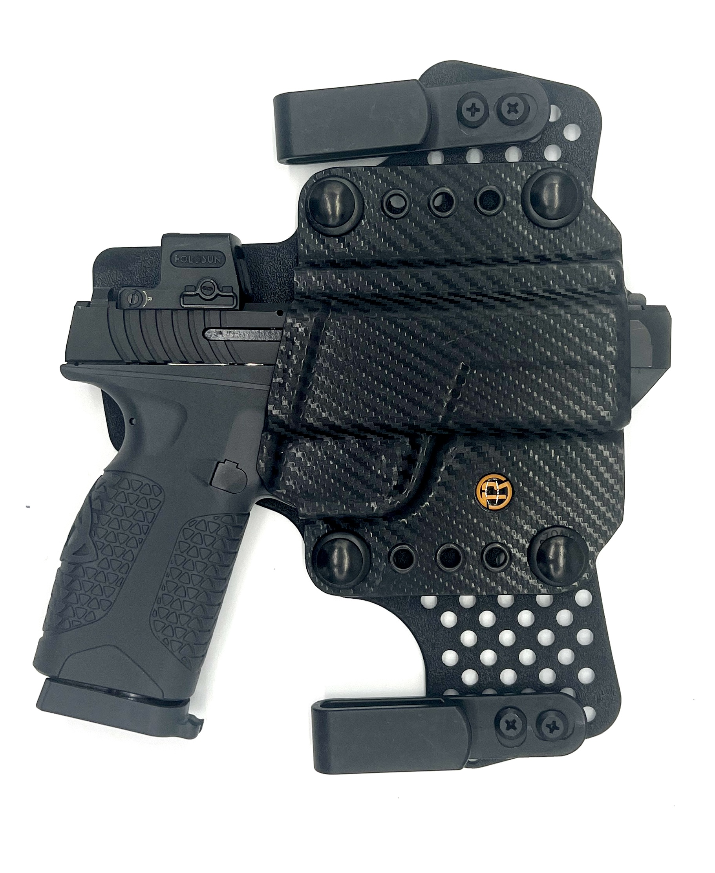
Regarded by many as the industry’s safest holsters, TACRIG systems add just .06 inch via a second rear layer to eliminate the potential for trigger manipulation from the back. Multi-platform shells also allow you to move the firearm with you instead of routinely drawing and holstering – when most accidents happen. The holsters can be configured for IWB, OWB or attached to hardpoint. Finally, TACRIG holsters boast a breathable back layer with 15-degree cant and 3mm top flare for easier, safter holstering. TACRIG holsters are constructed of mil-spec grade American-made Boltaron shells, allow for easier grip access and are compatible with mounted optics, as well as suppressor-height sights. The TACRIG Avidity Arms PD10 IWB FLEX Holster is now available at www.TACRIG.com.

JM4 Tactical Holsters
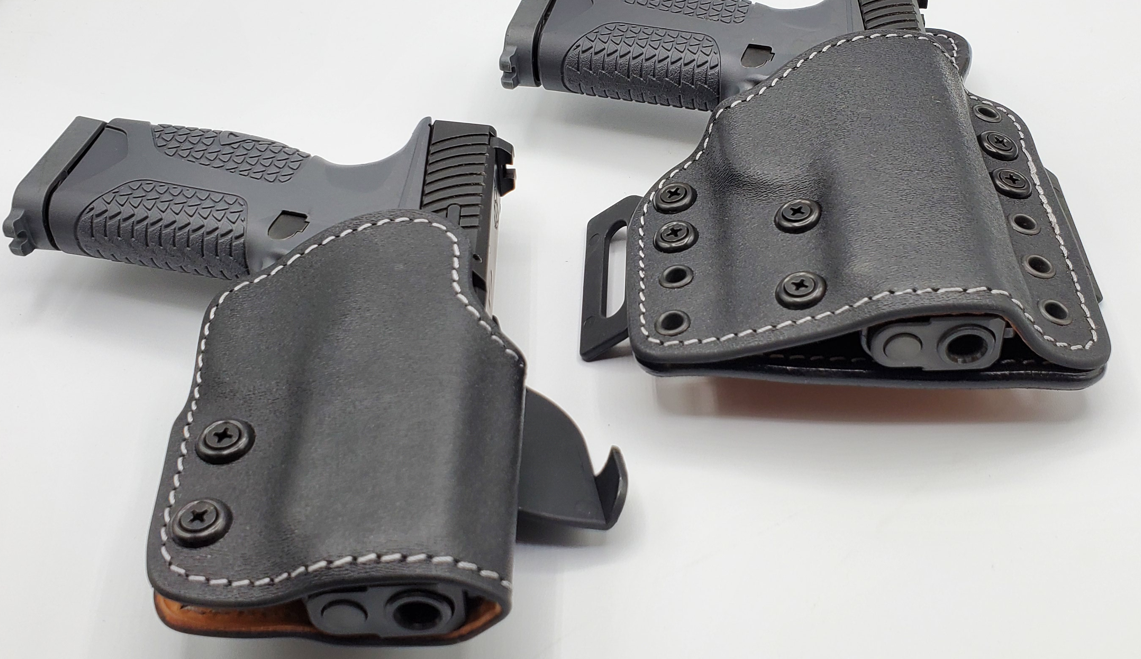
Premium Texan holster maker, JM4 Tactical offers three custom, made-to-order Avidity Arms PD10 handgun compatible holsters, including two for the new patent-pending Relic line – Lonestar Relic OWB, Relic Appendix IWB and Paddle OWB. All three models boast Grade A Hermann Oak leather for whisper-quiet drawing and holstering, and Boltaron polymer non-collapsible shells. Designed for wear at the 4 o’clock position, the Lonestar Relic also features fully adjustable ride height, cant and retention, and is available with quick-release or belt-feed clip systems.

G-Code Holsters
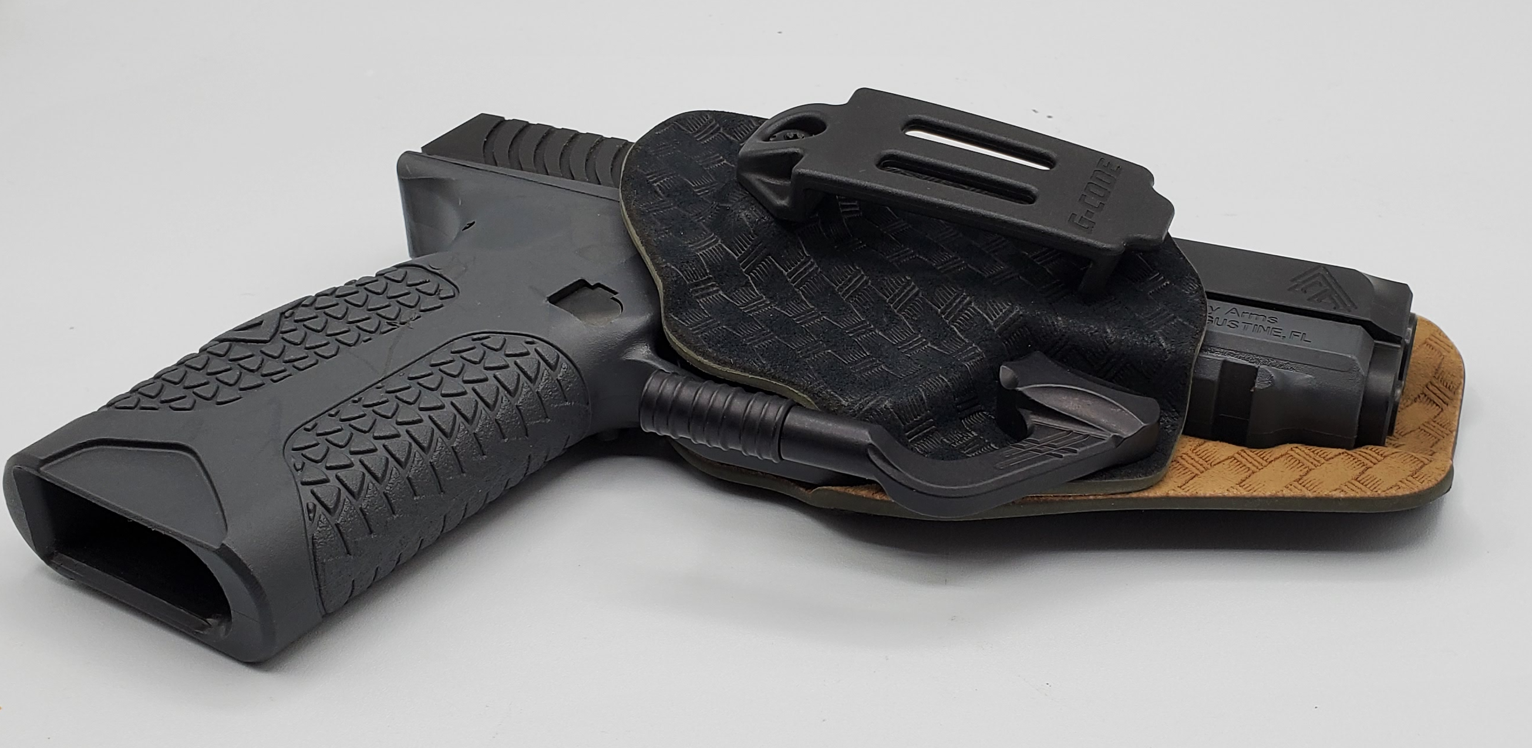
G-Code offers premium American-made Avidity PD10 Phenom Stealth IWB and Syncron OWB molded holster systems. G-Code’s patent-pending Phenom Stealth IWB Holster is designed for strong-size, cross-draw and appendix carrying, and boasts a proprietary mounting system for quick drawing and holstering on and off the belt. The Phenom Stealth also features hard-anodized, 6061 precision-machined aluminum MoClaw device. The MoClaw is designed to press the grip against the wearer and, along with the Phenom Stealth’s slim profile, works to eliminate printing. The Syncron is tension adjustable, fits RMR optics and suppressor-height sights, compatible with all of G-Code’s mounting platforms and is designed for maximum OWB concealability. With either holster, customers can configure an almost limitless combination of textures, colors, patterns and other details when purchasing.

About Avidity Arms Learn More:
Avidity Arms passionately approaches the art of design and the science of engineering with a focus on personal defense. The Avidity Arms company was first conceived in 2013 but took almost a decade to launch its first product, the PD10 Pistol. Since Avidity Arms’ inception, the team’s focus on delivering the best concealed-carry pistol has been unrelenting. In a business world where the only constant is change, and a personal defense arena where the stakes may be lifechanging, Avidity Arms remains committed to continuous improvement, best-in-class handguns and world-class customer service. All Avidity Arms product development, testing, manufacturing and service is headquartered in Fletcher, North Carolina. Learn more at www.AvidityArms.com.

